W-19
YEAR 10 SCIENCE (ADJUSTED)
PHYSICAL SCIENCE
TEST 1

Name: Mark: $\frac{}{\text{18}}$

Part 1: Multiple Choice

Write your choice for each question in the table below.

1. Speed is a measure of the rate:

(a) at which distance is covered.
(b) at which speed increases.
(c) of change in force.
(d) of change in acceleration.

2. Belinda walks a total distance of 1200 metres to school each
morning. If this trip takes her 800 seconds, her average speed
would be:

(a) 1.5 m/s.
(b) 0.67 m/s.
(c) 0 m/s.
MULTIPLE CHOICE ANSWERS
1
2
3
4
5
6

(d) 960,000 m/s.
sp
d
t
3. A car is driven along a highway at an average speed of 90 km/h for
2 hours without a rest stop. What distance has it covered?

(a) 45 km
(b) 180 km
(c) 360 km
(d) Not enough information is given to calculate.

4. An object moves with a speed of 5 m/s for 15 seconds. What distance has it travelled?

(a) 3 m
(b) 10 m
(c) 60 m
(d) 75 m

5. A car travels 400 km on a highway at a speed of 80 km/h. What time does the trip take?

(a) 0.5 hours
(b) 5 hours
(c) 20 hours
(d) 50 hours

6. The sample of ticker tape below shows:

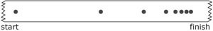

(a) a uniformly accelerating vehicle.
(b) a vehicle travelling at a constant velocity.
(c) a stationary vehicle.
(d) a uniformly decelerating vehicle.

Part 2: Short Answer

1. Describe or define the following terms. (2 marks)

(a) distance:

(b) displacement:

2. Complete the following table on speed calculations. Make sure you include the appropriate units for each quantity.
(3 marks)
sp
d
t

Distance travelled | Time taken | Average speed
490 m | 35 s
 | 12 s | 23 m/s
121 m |  | 11 m/s

3. The map below shows Broome and Alice Springs. Use the map (look at it carefully) and its scale to work out the following.

(a) The distance between Broome Airport and Alice Springs airport on the road. (1 mark)

(b) The displacement between the two airports - start from Broome.
(HINT: Don't forget to include a bearing.) (3 marks)

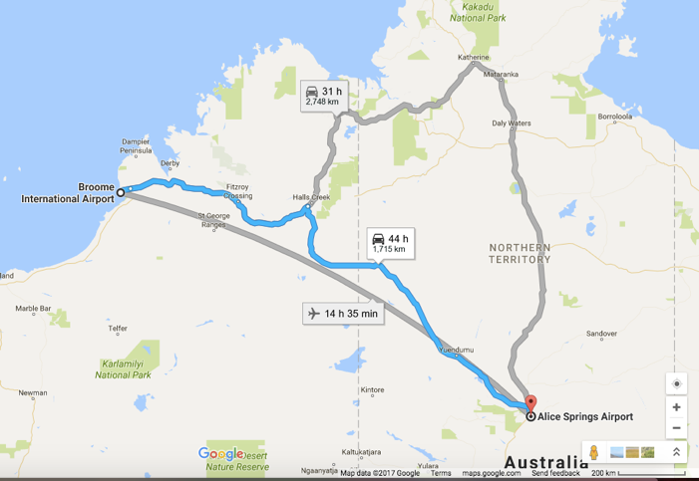

4. Decide whether the following are true (T) or false (F). (3 marks)

• Average speed = distance ÷ time.

• A swimmer who does 2 laps of a 50 m pool travels a distance of 100 m.

• The relationship between time, distance and speed is $t =\frac{sp}{d}$ .

